**CS 590: Topics in Computer Science**

**Assignment 08: MIPS Assembly Instructions and MIPS GCC**

Load MIPS_ex1.s into MARS and assemble the code. Assume that: fib[0] = 0; fib[1] = 1; fib[n] = fib[n-1] + fib[n-2]

Use Help (icon with the question mark) in order to answer the following questions about how to use MARS.

What do the .data, .word, .text directives mean (i.e., what do you put in each section)?

* .data : Subsequent items stored in Data segment at next available address
* .text : Subsequent items (instructions) stored in Text segment at next available address
* .word: Store the listed value(s) as 32 bit words on word boundary

How do you set a breakpoint in MARS? Set breakpoint on line 15

Assemble the code (F3).

Make sure to view the Execute tab.

In the Text segment, click the Bkpt (breakpoint) checkbox on line 15 (at address 0x00400038)

After your program stops because of a breakpoint, how do you continue to execute your code?

Click go button (F5) in toolbar

How do you step through your code?

Click step button(F7) in toolbar

How can you find out the contents of a register?

You can find out list of contents of registers at register tab in right side.

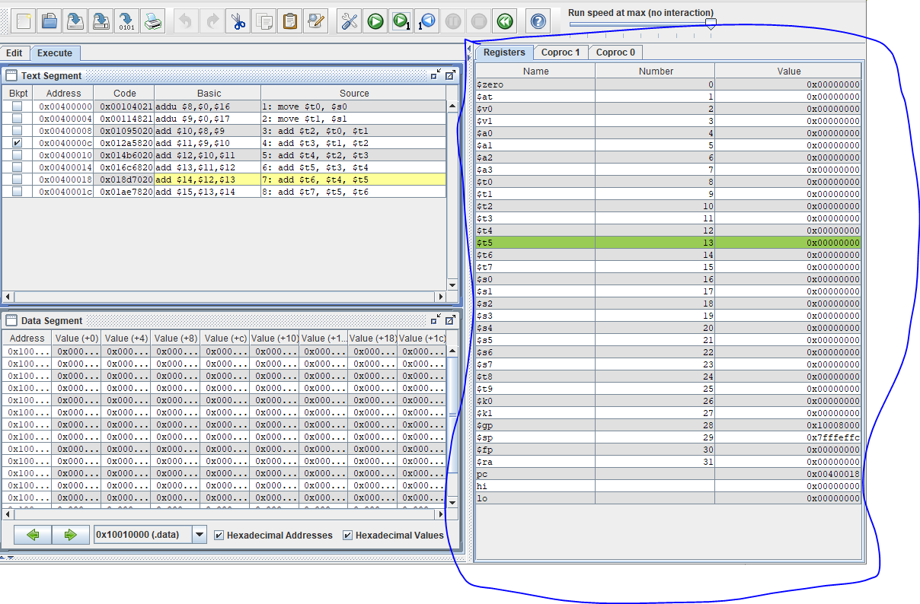

How do you modify the value of a register?

Double-click the current register or select register and press F2 in register tab.

At what address is n stored in memory?

.data segment 0x10010000

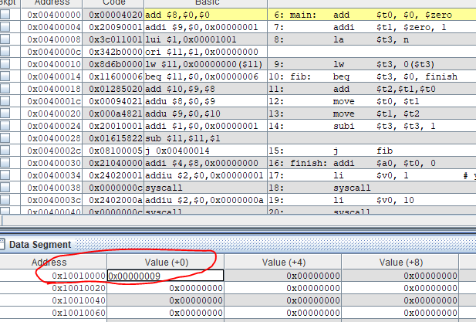

Calculate the 13th fib number by modifying this memory location.

Modify the content by 0x0000000c (12 ) and go. The result is 144 in Run I/O terminal down.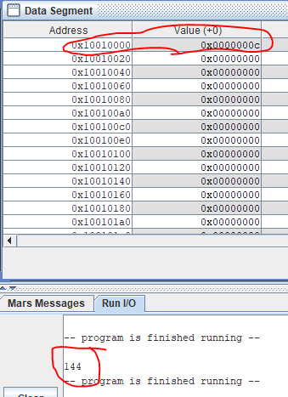

line 16 and 18 use syscall instruction. What is it and how do you use it? (hint: syscall inside Help!)

As you can see bellow,

addi $a0, $t0, 0 # set parameter for print out.

li $v0, 1 # service 1 indicate syscall for print integer to compiler

syscall

li $v0, 10 # service 0 indicate syscall for exit terminate execution

to compiler

syscall

I will give you help documentation

**SYSCALL functions available in MARS**

**Introduction**

A number of system services, mainly for input and output, are available for use by your MIPS program. They are described in the table below.

MIPS register contents are not affected by a system call, except for result registers as specified in the table below.

**How to use SYSCALL system services**

Step 1. Load the service number in register $v0.  
Step 2. Load argument values, if any, in $a0, $a1, $a2, or $f12 as specified.  
Step 3. Issue the SYSCALL instruction.  
Step 4. Retrieve return values, if any, from result registers as specified.  
**Example: display the value stored in $t0 on the console**

li $v0, 1 # service 1 is print integer

add $a0, $t0, $zero # load desired value into argument register $a0, using pseudo-op

syscall

**Table of Available Services**

|  |  |  |  |
| --- | --- | --- | --- |
| **Service** | **Code in $v0** | **Arguments** | **Result** |
| print integer | 1 | $a0 = integer to print |  |
| print float | 2 | $f12 = float to print |  |
| print double | 3 | $f12 = double to print |  |
| print string | 4 | $a0 = address of null-terminated string to print |  |
| read integer | 5 |  | $v0 contains integer read |
| read float | 6 |  | $f0 contains float read |
| read double | 7 |  | $f0 contains double read |
| read string | 8 | $a0 = address of input buffer $a1 = maximum number of characters to read | *See note below table* |
| sbrk (allocate heap memory) | 9 | $a0 = number of bytes to allocate | $v0 contains address of allocated memory |
| exit (terminate execution) | 10 |  |  |
| print character | 11 | $a0 = character to print | *See note below table* |
| read character | 12 |  | $v0 contains character read |
| open file | 13 | $a0 = address of null-terminated string containing filename $a1 = flags $a2 = mode | $v0 contains file descriptor (negative if error). *See note below table* |
| read from file | 14 | $a0 = file descriptor $a1 = address of input buffer $a2 = maximum number of characters to read | $v0 contains number of characters read (0 if end-of-file, negative if error). *See note below table* |
| write to file | 15 | $a0 = file descriptor $a1 = address of output buffer $a2 = number of characters to write | $v0 contains number of characters written (negative if error). *See note below table* |
| close file | 16 | $a0 = file descriptor |  |
| exit2 (terminate with value) | 17 | $a0 = termination result | *See note below table* |
| *Services 1 through 17 are compatible with the SPIM simulator, other than Open File (13) as described in the Notes below the table. Services 30 and higher are exclusive to MARS.* | | | |
| time (system time) | 30 |  | $a0 = low order 32 bits of system time $a1 = high order 32 bits of system time. *See note below table* |
| MIDI out | 31 | $a0 = pitch (0-127) $a1 = duration in milliseconds $a2 = instrument (0-127) $a3 = volume (0-127) | Generate tone and return immediately. *See note below table* |
| sleep | 32 | $a0 = the length of time to sleep in milliseconds. | Causes the MARS Java thread to sleep for (at least) the specified number of milliseconds. This timing will not be precise, as the Java implementation will add some overhead. |
| MIDI out synchronous | 33 | $a0 = pitch (0-127) $a1 = duration in milliseconds $a2 = instrument (0-127) $a3 = volume (0-127) | Generate tone and return upon tone completion. *See note below table* |
| print integer in hexadecimal | 34 | $a0 = integer to print | Displayed value is 8 hexadecimal digits, left-padding with zeroes if necessary. |
| print integer in binary | 35 | $a0 = integer to print | Displayed value is 32 bits, left-padding with zeroes if necessary. |
| print integer as unsigned | 36 | $a0 = integer to print | Displayed as unsigned decimal value. |
| (not used) | 37-39 |  |  |
| set seed | 40 | $a0 = i.d. of pseudorandom number generator (any int). $a1 = seed for corresponding pseudorandom number generator. | No values are returned. Sets the seed of the corresponding underlying Java pseudorandom number generator (java.util.Random). *See note below table* |
| random int | 41 | $a0 = i.d. of pseudorandom number generator (any int). | $a0 contains the next pseudorandom, uniformly distributed int value from this random number generator's sequence. *See note below table* |
| random int range | 42 | $a0 = i.d. of pseudorandom number generator (any int). $a1 = upper bound of range of returned values. | $a0 contains pseudorandom, uniformly distributed int value in the range 0 = [int] [upper bound], drawn from this random number generator's sequence. *See note below table* |
| random float | 43 | $a0 = i.d. of pseudorandom number generator (any int). | $f0 contains the next pseudorandom, uniformly distributed float value in the range 0.0 = f 1.0 from this random number generator's sequence. *See note below table* |
| random double | 44 | $a0 = i.d. of pseudorandom number generator (any int). | $f0 contains the next pseudorandom, uniformly distributed double value in the range 0.0 = f 1.0 from this random number generator's sequence. *See note below table* |
| (not used) | 45-49 |  |  |
| ConfirmDialog | 50 | $a0 = address of null-terminated string that is the message to user | $a0 contains value of user-chosen option 0: Yes 1: No 2: Cancel |
| InputDialogInt | 51 | $a0 = address of null-terminated string that is the message to user | $a0 contains int read $a1 contains status value 0: OK status -1: input data cannot be correctly parsed -2: Cancel was chosen -3: OK was chosen but no data had been input into field |
| InputDialogFloat | 52 | $a0 = address of null-terminated string that is the message to user | $f0 contains float read $a1 contains status value 0: OK status -1: input data cannot be correctly parsed -2: Cancel was chosen -3: OK was chosen but no data had been input into field |
| InputDialogDouble | 53 | $a0 = address of null-terminated string that is the message to user | $f0 contains double read $a1 contains status value 0: OK status -1: input data cannot be correctly parsed -2: Cancel was chosen -3: OK was chosen but no data had been input into field |
| InputDialogString | 54 | $a0 = address of null-terminated string that is the message to user $a1 = address of input buffer $a2 = maximum number of characters to read | *See Service 8 note below table* $a1 contains status value 0: OK status. Buffer contains the input string. -2: Cancel was chosen. No change to buffer. -3: OK was chosen but no data had been input into field. No change to buffer. -4: length of the input string exceeded the specified maximum. Buffer contains the maximum allowable input string plus a terminating null. |
| MessageDialog | 55 | $a0 = address of null-terminated string that is the message to user $a1 = the type of message to be displayed: 0: error message, indicated by Error icon  1: information message, indicated by Information icon  2: warning message, indicated by Warning icon  3: question message, indicated by Question icon  other: plain message (no icon displayed) | N/A |
| MessageDialogInt | 56 | $a0 = address of null-terminated string that is an information-type message to user $a1 = int value to display in string form after the first string | N/A |
| MessageDialogFloat | 57 | $a0 = address of null-terminated string that is an information-type message to user $f12 = float value to display in string form after the first string | N/A |
| MessageDialogDouble | 58 | $a0 = address of null-terminated string that is an information-type message to user $f12 = double value to display in string form after the first string | N/A |
| MessageDialogString | 59 | $a0 = address of null-terminated string that is an information-type message to user $a1 = address of null-terminated string to display after the first string | N/A |

**NOTES: Services numbered 30 and higher are not provided by SPIM**  
**Service 8** - Follows semantics of UNIX 'fgets'. For specified length n, string can be no longer than n-1. If less than that, adds newline to end. In either case, then pads with null byte If n = 1, input is ignored and null byte placed at buffer address. If n 1, input is ignored and nothing is written to the buffer.  
**Service 11** - Prints ASCII character corresponding to contents of low-order byte.  
**Service 13** - MARS implements three flag values: 0 for read-only, 1 for write-only with create, and 9 for write-only with create and append. It ignores mode. The returned file descriptor will be negative if the operation failed. The underlying file I/O implementation uses java.io.FileInputStream.read() to read and java.io.FileOutputStream.write() to write. MARS maintains file descriptors internally and allocates them starting with 3. File descriptors 0, 1 and 2 are always open for: reading from standard input, writing to standard output, and writing to standard error, respectively (new in release 4.3).  
**Services 13,14,15** - In MARS 3.7, the result register was changed to $v0 for SPIM compatability. It was previously $a0 as erroneously printed in Appendix B of *Computer Organization and Design,*.  
**Service 17** - If the MIPS program is run under control of the MARS graphical interface (GUI), the exit code in $a0 is ignored.  
**Service 30** - System time comes from java.util.Date.getTime() as milliseconds since 1 January 1970.  
**Services 31,33** - Simulate MIDI output through sound card. Details below.  
**Services 40-44** use underlying Java pseudorandom number generators provided by the java.util.Random class. Each stream (identified by $a0 contents) is modeled by a different Random object. There are no default seed values, so use the Set Seed service (40) if replicated random sequences are desired.

**Example of File I/O**

The sample MIPS program below will open a new file for writing, write text to it from a memory buffer, then close it. The file will be created in the directory in which MARS was run.

# Sample MIPS program that writes to a new file.

# by Kenneth Vollmar and Pete Sanderson

.data

fout: .asciiz "testout.txt" # filename for output

buffer: .asciiz "The quick brown fox jumps over the lazy dog."

.text

###############################################################

# Open (for writing) a file that does not exist

li $v0, 13 # system call for open file

la $a0, fout # output file name

li $a1, 1 # Open for writing (flags are 0: read, 1: write)

li $a2, 0 # mode is ignored

syscall # open a file (file descriptor returned in $v0)

move $s6, $v0 # save the file descriptor

###############################################################

# Write to file just opened

li $v0, 15 # system call for write to file

move $a0, $s6 # file descriptor

la $a1, buffer # address of buffer from which to write

li $a2, 44 # hardcoded buffer length

syscall # write to file

###############################################################

# Close the file

li $v0, 16 # system call for close file

move $a0, $s6 # file descriptor to close

syscall # close file

###############################################################

**Using SYSCALL system services 31 and 33: MIDI output**

These system services are unique to MARS, and provide a means of producing sound. MIDI output is simulated by your system sound card, and the simulation is provided by the javax.sound.midi package.

Service 31 will generate the tone then immediately return. Service 33 will generate the tone then sleep for the tone's duration before returning. Thus it essentially combines services 31 and 32.

This service requires four parameters as follows:

|  |  |  |  |
| --- | --- | --- | --- |
| **pitch ($a0)**   * Accepts a positive byte value (0-127) that denotes a pitch as it would be represented in MIDI * Each number is one semitone / half-step in the chromatic scale. * 0 represents a very low C and 127 represents a very high G (a standard 88 key piano begins at 9-A and ends at 108-C). * If the parameter value is outside this range, it applies a default value 60 which is the same as middle C on a piano. * From middle C, all other pitches in the octave are as follows:  |  |  |  | | --- | --- | --- | | * 61 = C# or Db * 62 = D * 63 = D# or Eb * 64 = E or Fb | * 65 = E# or F * 66 = F# or Gb * 67 = G * 68 = G# or Ab | * 69 = A * 70 = A# or Bb * 71 = B or Cb * 72 = B# or C |  * To produce these pitches in other octaves, add or subtract multiples of 12. |
| **duration in milliseconds ($a1)**   * Accepts a positive integer value that is the length of the tone in milliseconds. * If the parameter value is negative, it applies a default value of one second (1000 milliseconds). |
| **instrument ($a2)**   * Accepts a positive byte value (0-127) that denotes the General MIDI "patch" used to play the tone. * If the parameter is outside this range, it applies a default value 0 which is an *Acoustic Grand Piano*. * General MIDI standardizes the number associated with each possible instrument (often referred to as *program change* numbers), however it does not determine how the tone will sound. This is determined by the synthesizer that is producing the sound. Thus a *Tuba* (patch 58) on one computer may sound different than that same patch on another computer. * The 128 available patches are divided into instrument families of 8:  |  |  |  |  | | --- | --- | --- | --- | | 0-7 | Piano | 64-71 | Reed | | 8-15 | Chromatic Percussion | 72-79 | Pipe | | 16-23 | Organ | 80-87 | Synth Lead | | 24-31 | Guitar | 88-95 | Synth Pad | | 32-39 | Bass | 96-103 | Synth Effects | | 40-47 | Strings | 104-111 | Ethnic | | 48-55 | Ensemble | 112-119 | Percussion | | 56-63 | Brass | 120-127 | Sound Effects |  * Note that outside of Java, General MIDI usually refers to patches 1-128. When referring to a list of General MIDI patches, 1 must be subtracted to play the correct patch. For a full list of General MIDI instruments, see [www.midi.org/about-midi/gm/gm1sound.shtml](http://www.midi.org/). The General MIDI channel 10 percussion key map is not relevant to the toneGenerator method because it always defaults to MIDI channel 1. |
| **volume ($a3)**   * Accepts a positive byte value (0-127) where 127 is the loudest and 0 is silent. This value denotes MIDI velocity which refers to the initial attack of the tone. * If the parameter value is outside this range, it applies a default value 100. * MIDI velocity measures how hard a *note on* (or *note off*) message is played, perhaps on a MIDI controller like a keyboard. Most MIDI synthesizers will translate this into volume on a logarithmic scale in which the difference in amplitude decreases as the velocity value increases. * Note that velocity value on more sophisticated synthesizers can also affect the timbre of the tone (as most instruments sound different when they are played louder or softer). |

**Exercise 2:** A short MIPS program

Write a piece of MIPS code that, given values in $s0 and $s1, put into the $t? registers the following:

|  |
| --- |
| $t0 = $s0 $t1 = $s1  $t2 = $t0 + $t1  $t3 = $t1 + $t2  ...  $t7 = $t5 + $t6 |

In other words, for each register from $t2 to $t7, it stores the sum of the previous two $t? register values. The $s0 and $s1 registers contain the initial values.

Don't set the value of $s0 and $s1 in your code. Instead, learn how to set it manually with

MARS. Save your code in a file called MIPS_ex2.s

**Exercise 3:** Debugging a MIPS program

Debug the loop in the program in MIPS_ex3.s. It is meant to copy integers from memory address $a0 to memory address $a1, until it reads a zero value. The number of integers copied (up to, but NOT including the zero value), should be stored in $v0.

Describe in a file MIPS_ex3.txt the bug(s) of the code. Create a file MIPS_ex3_ok.s that contains a bug fixed version of MIPS_ex3.s

**Exercise 4:** Compiling from C to MIPS

The file MIPS_ex4.c is a C version of the program in the previous part of the lab. Compile this program into MIPS code using the command (if working in the

Linux server):

mips-linux-gnu-gcc -S -O2 -fno-delayed-branch MIPS_ex4.c -o MIPS_ex4.s

If working in Toolman use:

mips64-linux-gnu-gcc -S -O2 -fno-delayed-branch MIPS_ex4.c -o MIPS_ex4.s

The -O2 option (letter "O" and 2) turns on a level of optimization. The -S option generates assembly code. The above command should generate assembly language output for the C code. Please note that you will not be able to run this code through MARS.

Find the assembly code for the loop that copies source values to destination values. Then, find where the source and dest pointers you see in MIPS_ex4.c are originally stored in the assembly file. Finally, explain how these pointers are manipulated through the loop.

Find the section of code in MIPS_ex4.s that corresponds to the copying loop and explain how each line is used in manipulating the pointer.

Variable dest and source is indicated by address in memory, so the address of specific time when current operation is introduced are increase by 4 than previous stage.

But the contents of dest and source is not changed until end.

**Questions:**

1. Explain in a paragraph how the Spectre malware exploits speculative execution in the CPU.
2. Why does Spectre not require to exploit any software vulnerabilities?
3. Explain why vulnerable speculative execution implementations, found in most microprocessors, violate the security assumptions.
4. What is a side channel attack? Give one example.

**Conclusion**

* + All codes are stored in .text segment.
  + All data are stored in .data segment and we should confirm the range of available address when Memory access about data.
  + The content of register indicated address must increase or decrease by every 4 in operation.
  + Cannot copy contents in memory into specific memory address, so should use sw and lw instruction in that case which do access memory with address.